**RRV Pinot Forum Vineyard Practices**

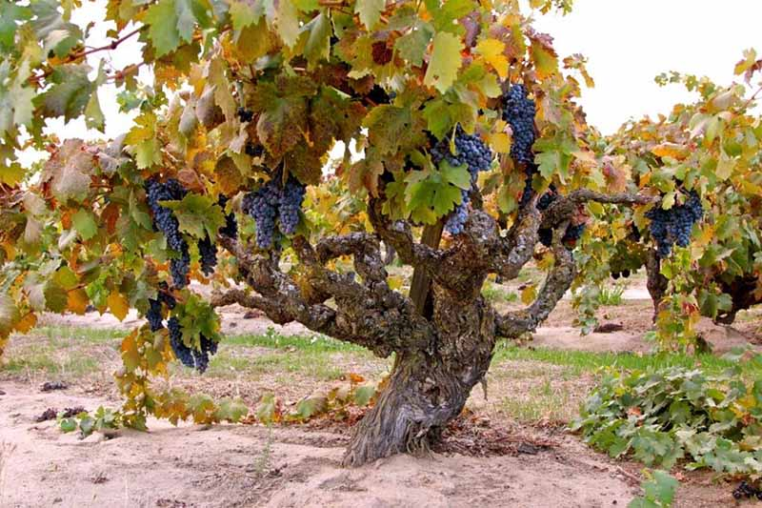

**VSP (Vertical Shoot-Positioned)**

**Pros:** good fruit exposure, easy to work fruit or canopy, row spacing can be tight, efficient use of land

**Cons:** fruit can betoo exposed, leaves shaded or even smashed together, more green flavors (pyrazines) in certain varieties

**Modifications:** add crossarms to open the canopy into a “V” shape to more optimal canopy exposure while decreasing fruit exposure

**Quad (horizontally divided canopy)**

**Pros:** great for vigorous soils as each vine bears more fruit and brings vine into balance; good balanced sun exposure, increased yield and quality from balanced vines

**Cons:** higher set up costs due to more steel and wires, weak vines if mistakenly set up on low vigor soils, harder to work interior of vines

**Modifications:** Lyre (shown), Elkhorn (vertical arms splay out with wider reach)

**Head Trained (Goblet)**

**Pros:** balanced leaf/fruit exposure, shaded in hot climates, many old sites are dry farmed

**Cons:** inefficient use of land, fewer vines, low yields, less wine so wines cost more

**Modifications:** vertically head trained (see next pic) where vine is grown straight up a post with spurs and canes coming out all around the sides like a brush, making more efficient use of the land, but more shaded fruit at the bottom

**Head Trained (Vertically)** – see above

**Two-Wire (California Sprawl)**

**Pros:** simple system, low cost of installment, good fruit exposure, easy to prune, easily mechanized

**Cons:** fruit can be too shaded, increased humidity from canopy blocking airflow through the rows, so increased disease pressure

**Modifications:** GDC (Geneva Double Curtain – see next pic) which is simply a California Sprawl grown in a Quad, potentially trapping even more humidity

**GDC (Geneva Double Curtain)** – see above

**Scott Henry**

**Pros:** spreads out vigor like a Quad but maintains tight row spacing like VSP, good fruit exposure, efficient use of land, easy to work fruit, good yields

**Cons:** need to crack canes or train spurs down, traps humidity/increases disease pressure due to decreased airflow, fighting the vine’s tendency to grow upward

**Modifications:** ?

**Smart-Henry**

**Pros:** Increased root competition to decrease vigor, efficient use of land, good yields

**Cons:** traps humidity/increases disease pressure, fighting the vine’s tendency to grow upward

**Modifications:** ?

**Smart-Dyson**

**Pros:** good shoot spacing, good fruit and canopy exposure, efficient use of land, easy to work fruit

**Cons:** traps humidity/increases disease pressure, but not as much as Scott Henry or Smart-Henry, fighting the vine’s tendency to grow upward

**Modifications:** ?

Graphics from *Wine Grape Varieties in California*

by L. Peter Christensen, Nick K. Dokoozlian, et al